Project Design Document

1. Design Intent
• What experience are you trying to create?
A playful and interactive experience where users feel like they are engaging with a real, shy creature. The aim is to create a sense of curiosity and delight through simple actions like moving closer, touching, and showing colours, making the toy feel alive and responsive. This is extended through a fun “tippi tippi tip top” style colour game, where users are given a random colour and have to quickly find and match it in real life, making the interaction more active and engaging.
• Who is it for?
It is designed mainly for children aged 6–12, as well as anyone who enjoys cute, interactive objects. It can also appeal to people interested in simple tech-based toys and engaging physical interactions, especially in a playful group setting.
• If solving a problem, what problem does it solve?
This project does not directly solve a problem but focuses on creating an engaging and joyful interaction. It encourages curiosity and playful learning by introducing users to basic concepts of sensors and responsive design in a fun and interactive way, especially through the added colour-matching game.

2. Inspiration & References
- Inspiration & References
A few real toys and DIY projects really inspired our idea for Pascal – The Shy Chameleon. They all use lights, movement, and sensors to make a chameleon feel like a little character that reacts to people.
Existing products / ideas
We looked at a few things that are similar in spirit to what we made:
- A colour-changing electronic chameleon built with an Arduino and a colour sensor. The chameleon changes its LED colour depending on the colour of the surface it “sees”, which made us think about how simple light changes can already feel very expressive.
  - Link: https://www.instructables.com/COLOUR-CHANGING-ELECTRONIC-CHAMELEON/
- A robotic chameleon kit called “My Robotic Pet: Coding Chameleon”, where you build a chameleon that uses an infrared sensor, a colour sensor, and RGB LEDs. It can hide from you, change colour, and even move its tongue, which showed us how sensors and simple behaviours can make a toy feel alive.
  - Link: https://store.thamesandkosmos.com/products/my-robotic-pet-coding-chameleon-coming-fall-2025?_pos=1&_psq=chameleon&_ss=e&_v=1.0
- A commercial light-up chameleon toy called “Sunny, Your Luminous Chameleon”, which reacts to touch and sound with changing colours and sounds. This reminded us how touching and lighting up a toy can make it feel playful and friendly.
  - Link: https://www.desertcart.in/products/430022922-sunny-your-luminous-chameleon-interactive-toy-with-touch-sensors-lights-express-emo
- A small DIY Arduino-based colour-changing chameleon on YouTube, where the creator makes a simple chameleon that changes its LED colour based on the colour placed in front of it.
  - Link: https://www.youtube.com/watch?v=cW63wS7RxKc
Images / links
Most of these pages and videos already have pictures or clips showing how the toys look and move. You can see the colour-changing LED patterns, the body shape, and how the chameleon reacts when someone comes near or touches it.
What did we learn from them?
From these examples, we learned that:
- Even a simple ring of LEDs or a single colour light can make the chameleon feel like it has a “mood” or personality if the colours change in a clear way.
- Using a colour sensor for colour-changes and an IR sensor for “shyness” (moving away when someone comes close) makes the behaviour easy to understand and fun to play with.
- Touch and gentle movement, like a wagging tail or small head-turn, help pull people into the toy and make them want to keep interacting.
- When the reactions are simple and predictable (hide when near, wag when touched, change colour when shown a colour), the toy feels more like a small character you can “talk” to, rather than just a machine.
All of this inspired us to keep Pascal’s mechanics simple (just a few sensors and two servo motors) but to make its reactions feel playful, shy, and a bit cute.

3. User Journey
- User starts by noticing Pascal : the shy chameleon sitting quietly, looking cute and still.
- User interacts by moving their hand closer to it, curious to see if it reacts.
- System responds by sensing the movement and slowly turning its head away, as if it feels shy.
- User interacts again by gently touching its hand.
- System responds by wagging its tail, showing a playful reaction.
- User then shows different colours to the chameleon.
- System responds by changing the colour of its ring to match what it sees.
- User continues exploring different actions, enjoying how Pascal reacts differently each time, making the interaction feel fun and alive.

4. Success Criteria
• Functional
All sensors and outputs respond within 1 second. The touch sensor reliably triggers the tail servo when touched, the IR sensor correctly detects proximity and moves the head accordingly, and the colour sensor accurately detects and displays colours on the NeoPixel ring with visible similarity to the input.
• User Experience
The interaction is simple and intuitive, users can easily understand how to trigger responses without instructions. The movements and colour changes feel natural, smooth, and engaging, making the toy enjoyable to use.
• Reliability
The system works consistently without random errors or failures. Sensors give stable readings, servos move without jitter, and the NeoPixel displays correct colours repeatedly over multiple uses.

5. System Overview
The system is designed as an interactive loop where sensors detect user actions and immediately translate them into physical or visual responses. At its core, the setup uses an ESP32 to continuously read inputs from different sensors and control outputs like servo motors and LEDs, allowing the chameleon to react in real time.
The first part of the system is the touch interaction. A capacitive touch sensor connected to GPIO 14 continuously reads capacitance values. When the user touches it (value drops below 200), the system triggers a servo motor to sweep between two positions (duty 35 → 110), creating a physical movement such as a tail wag or expressive gesture.
The second part handles proximity-based interaction. A digital IR obstacle sensor on GPIO 15 detects when an object comes close. When detection occurs (pin reads LOW), a second servo moves to a defined position, and when the object moves away, it returns to its default state. This allows the chameleon to respond to nearby presence, like turning its head away in a shy manner.
The third part focuses on colour interaction. A TCS-style colour sensor, controlled using S0–S3 multiplexer pins, reads red, green, and blue light frequencies from the environment. These values are calibrated and mapped to standard RGB values (0–255). The system then compares the detected colour with a predefined set using Euclidean distance to find the closest match. Once identified, all 16 NeoPixel LEDs are set to that colour, making the chameleon visually mirror what it sees.
Together, these components form a cohesive system where touch, proximity, and colour inputs are converted into expressive outputs, making the interaction feel responsive, dynamic, and lifelike.

6. High-Level Block Diagram
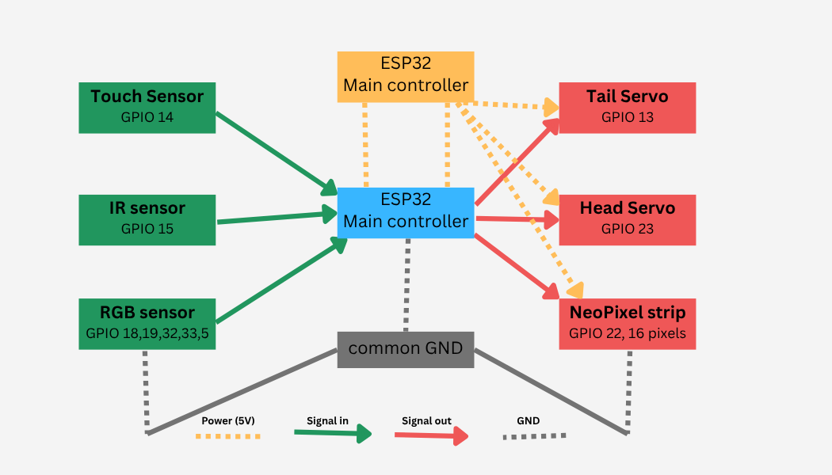

7. Input / Output Mapping
Input | Process | Output
Touch Sensor (GPIO 14) | Reads capacitance value; if value < 200, trigger condition | Servo motor sweeps (tail wag / gesture)
IR Obstacle Sensor (GPIO 15) | Detects object (LOW signal when close) | Servo moves to active position (head turns away), returns when clear
Color Sensor (RGB frequencies) | Reads R, G, B values → maps to 0–255 → matches closest colour | NeoPixel LEDs change to detected colour

8. Sketches & Concepts
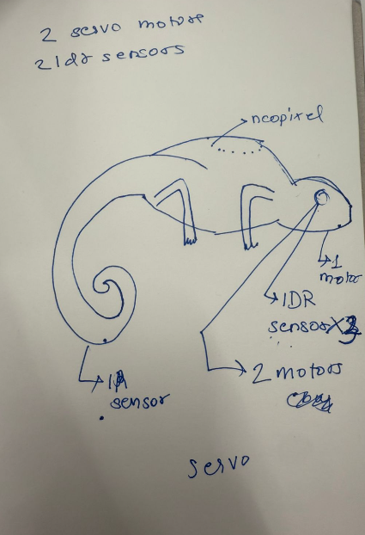

Final System Architecture (Labelled)
